WEEK 07 PRACTICE SESSION
ROLL NO:241801314
NAME:VIKASHINI.M
WEEK 07
Q1
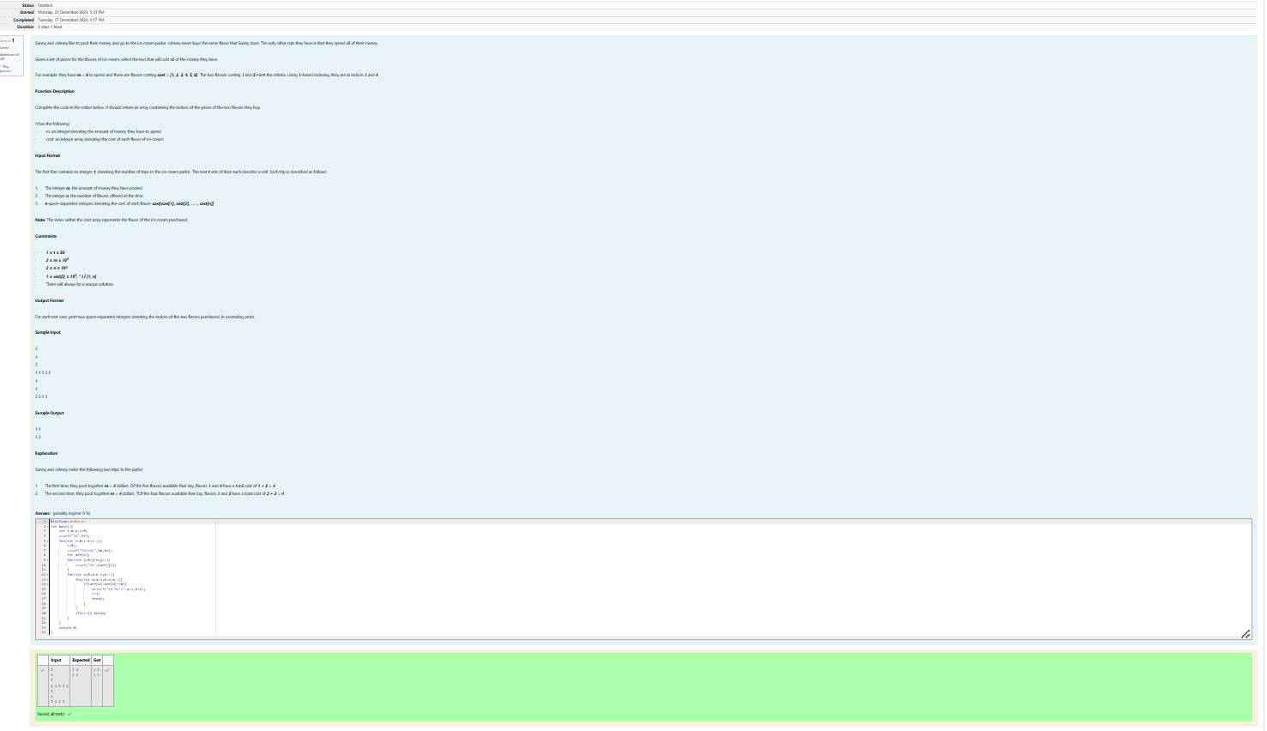
Q2
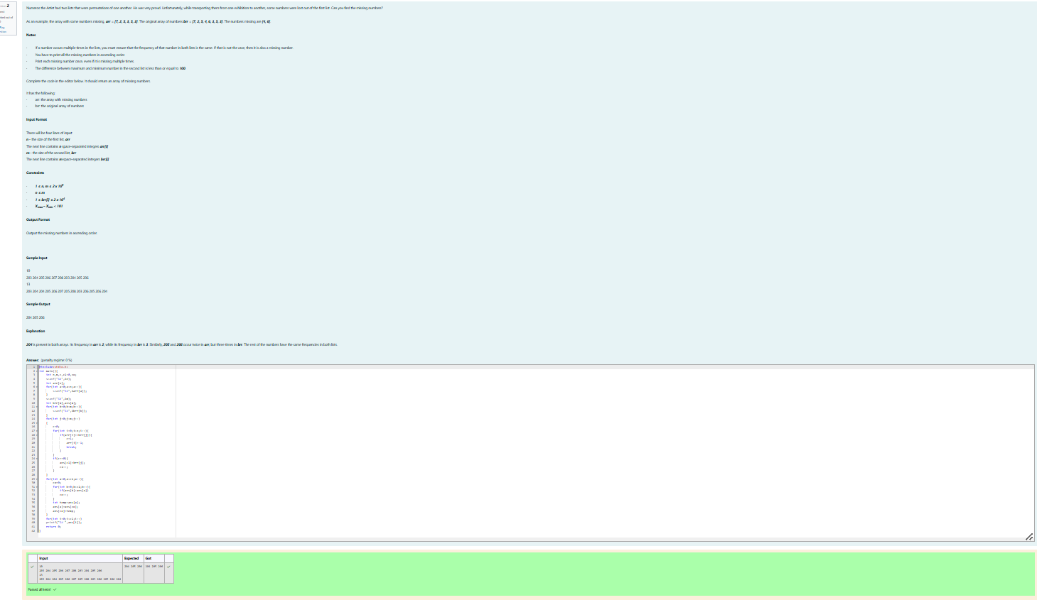
Q3
